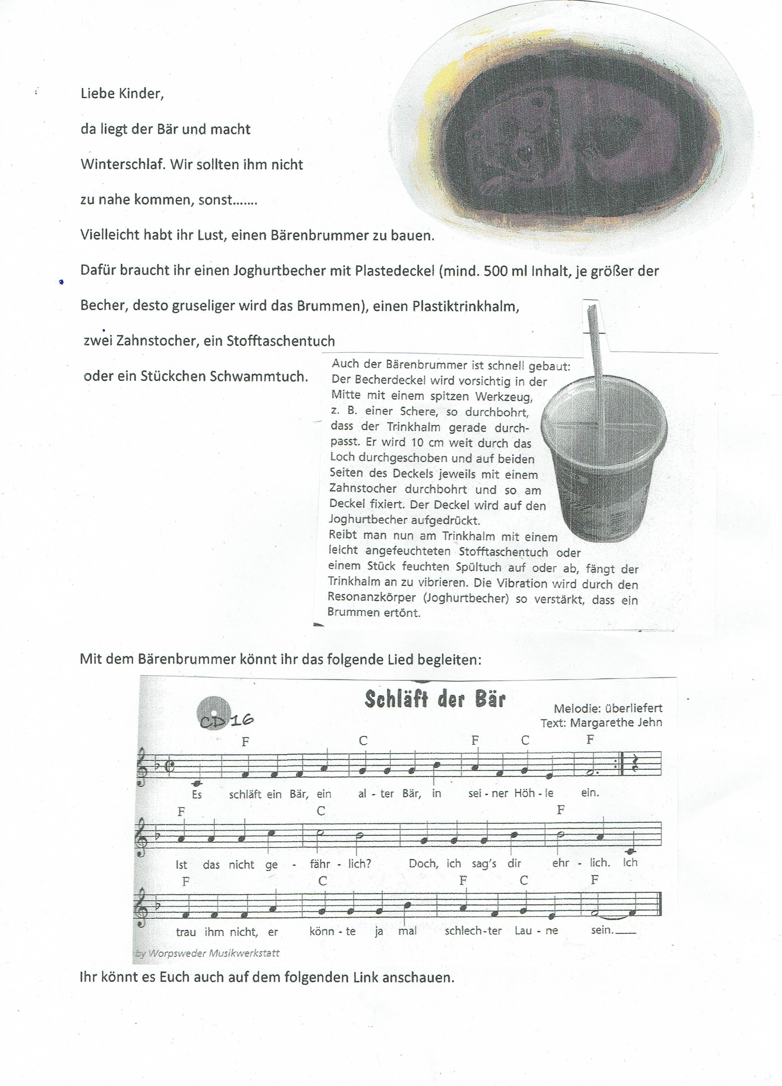

<https://www.dropbox.com/s/3ya1y1et7b9uzej/Schl%C3%A4ft%20der%20B%C3%A4r.mp4?dl=0>